

Bayview Village’s 399 Hillcrest Avenue

Description: A rare and special offering. Situated in the prestigious Bayview Village neighbourhood, this exceptional, 3,000 sq. ft., end unit, freehold executive townhome, winner of the 2013 Toronto Urban Design Award of Merit, combines contemporary architecture and sophistication.
The luxurious and customized finishings include a private elevator, a gourmet kitchen with stainless steel Sub-Zero and Wolf appliances, plank hardwood flooring, imported European light fixtures, opulent bathrooms and laundry room and a fire sprinkler system throughout.
The exterior has been professionally landscaped and utilizes a lawn sprinkler system.
Public transportation, both bus and subway service is easily accessible as is Bayview Village Shopping Centre and the YMCA.

MAIN FLOOR

Main Entrance
- Floating open hardwood staircase leading to second level with custom railing and metal pickets
- Tiled floor
- Clothes closet

2 Piece Powder Room
- Custom vanity & quartz counter-top
- Custom Duravit toilet
- Custom tiled floor & wall

Living Room – 15’2” x 13’5”
- Cathedral ceiling
- Floor to ceiling corner windows with northeast exposure
- Custom window covers
- Custom plank oak hardwood floor
- Imported European ceiling fan and light fixture
- Pot lights

SECOND LEVEL

Kitchen/Dining Room – 27’2” x 26’4”
- Waterfall breakfast island & custom cabinetry, inserts and Lazy Susan
- Wolf built-in oven drawer
- Bosch built-in dishwasher with stainless steel interior
- Wolf 4 burner gas stove with grill, barbeque and double oven
- Custom Best exhaust hood
- Double stainless steel sink
- Custom subway tiled backsplash
- Under cabinet lighting
- Oversized Sub-Zero fridge with 2 freezer drawers & Sub-Zero wine fridge with 2 Beverage drawers
- Custom European light fixtures
- Custom tiled floor
- Walk out to deck with wood flooring and West exposure
- Bay windows
- Hand woven natural blinds
- Pot lights

THIRD LEVEL

Custom Laundry Room
- Cherrywood cabinetry
- Custom tiled floor & wall
- Stainless steel laundry sink
- Stainless steel LG full size front load washer & dryer

Second Bedroom/Office – 12’3” x 16’1”
- Floor to ceiling corner windows with northeast exposure
- Custom window coverings
- Custom European light fixture
- Pot lights
- Custom plank oak hardwood floor
- Clothes closet

Master Bedroom – 14’3” x 15’9”
- Custom walk in clothes closet with frosted glass doors, custom floor to ceiling cupboards & built-ins
- Bay window with sun-filled west exposure
- Custom plank oak hardwood floor
- Imported European ceiling fan with light fixture
- Built-in safe
- Hand woven natural blinds
- Pot lights

Master Bedroom Ensuite
- Heated stone tiled floor & towel rack
- His & Hers sinks
- Custom vanity, faucets, pull outs & quartz counter-top
- Tiled walls
- Glass enclosed shower stall
- Soaker tub
- Separate room with toilet & washlet seat

UPPER LEVEL

Third Bedroom – 16’3” x 16’1”
- North East corner window
- Custom plank oak hardwood floor
- Triple wall-to-wall closet with sliding doors and custom built-ins
- Custom window covers
- Imported European light fixture

4 Piece Washroom

- Heated stone tiled floor & towel rack
- His & Hers sinks with quartz counter-top
- Vanity with custom pull outs
- Oversized glass enclosed shower stall
- Skylight
- Custom European light fixture

Fourth Bedroom – 11’7” x 13’5”
- Custom plank oak hardwood floor
- Imported European light fixture
- Walk out to deck with wood flooring and West exposure
- Freestanding wardrobe
- Triple wall to wall clothes closet with sliding doors & custom built-ins
- Hand woven natural blinds

LOWER LEVEL to Garage
- Tandem 2 car heated garage
- Epoxy floor
- Custom built-ins throughout
- Electric garage door opener

BASEMENT RECREATION ROOM – 11’3’ x 12’9”
- Upgraded broadloom
- Above grade window
- Custom European light fixture
- Under stair storage area
- 65” Panasonic Veira flat screen television

2 Piece Powder Room
- Custom vanity & quartz counter-top
- Custom Duravit toilet
- Custom tiled floor & wall

Extras Included
- Oversized, stainless steel Sub-Zero Fridge & 2 drawer freezer
- Sub-Zero stainless steel temperature controlled wine fridge with 2 beverage drawers
- Stainless steel Wolf 4 burner gas stove with grill, barbeque & double oven
- Stainless steel Bosch built-in dishwasher with stainless steel interior
- Stainless steel built-in Wolf oven drawer
- Stainless steel LG full size front loading washer & dryer
- Custom plank hardwood floors throughout
- Two (2) gas forced air furnaces
- Central air conditioner
- Security system
- Custom built-in closet organizers
- Fire sprinkler system throughout
- Custom garage stainless steel storage lockers & built-ins
- Custom imported electrical light fixtures
- Custom window coverings throughout
- Professionally landscaped with sprinkler system
- Solid mahogany front door (8.85 ft. tall)
- Limestone exterior

Maintenance Fees: $295.00/month
Taxes: $6,282.94/2015
Parking: Built-in garage with 2 tandem parking spaces
Possession: 60-90 days/TBA
Price: $1,688,000

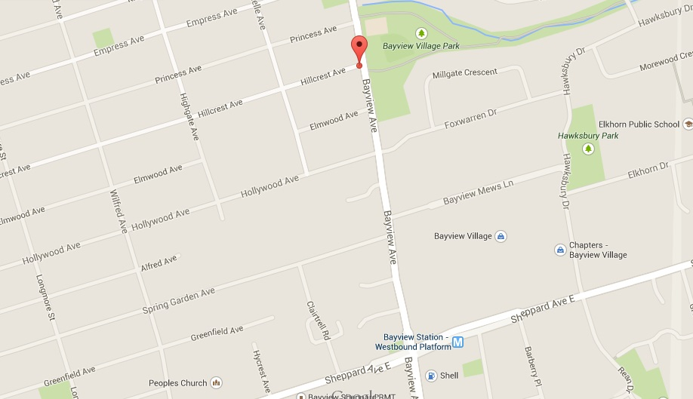






Rhonda and Perry are consistantly one of the top producing sales teams at Harvey Kalles Real Estate Ltd. In 2014 Rhonda and Perry received the Director's Circle Award for being in the top 20.
Of over 40, 795 MLS agents in the GTA, Rhonda and Perry were in the TOP 1.7% in sales and the TOP 3% in the number of units sold. (2014)
Rhonda and Perry's average sale was 36% higher than the Toronto Real Estate Board's average sale price.
We work hard because we love our work, and the results show!

Presented By:
Harvey Kalles Real Estate Ltd., Brokerage
2145 Avenue Road
Toronto, ON
M5M 4B2
T: 416.441.2888 ext 334, 335 & 508
F: 416.441.9926

Presented By:
Harvey Kalles Real Estate Ltd., Brokerage
2145 Avenue Road
Toronto, ON
M5M 4B2
T: 416.441.2888 ext 334, 335 & 508
F: 416.441.9926





Rhonda Abony & Perry Steinberg from Harvey Kalles Real Estate are pleased to announce we are affiliated with Juwai.com. The #1 Chinese International property portal, with over 2.5 million Chinese visiting each month.
About Juwai
Juwai, which means “home overseas”, is visited by thousands of Chinese buyers each day from over 315 cities throughout China, as well as major Chinese communities in Taiwan, Hong Kong, Malaysia and Singapore.
For our customers, we strive to be at the forefront of innovation of products and services, which assist them in growing their business by gaining exposure to Chinese buyers – the largest international property buying force.
Juwai introduced the first global platform to engage Chinese buyers in 2011. We pioneered global property Mandarin Mapping, international real estate data information in Chinese, and advanced property search in China.
The site is the largest and most authoritative source for global property in Chinese, with over 2.4 million property listings spanning 58 countries, with over 12,000 current news stories, country buying guides, education and emigration articles, along with the largest Chinese social media community focused on international property.
Juwai’s international operations are located in Hong Kong (Special Administrative Region of the People’s Republic of China), whilst the China operations are run from Shanghai and Guangzhou (People’s Republic of China).
If you, your friends or family are thinking of making a move, local or international, give us a call. We are here to help! Visit www.AbonySteinberg.com/links to see more of our affiliated companies.


